

CyberShield 360: Design and Analysis of an AI-Enabled Enterprise Cybersecurity Platform
Submitted in the partial fulfilment for the Course of

CSA1012 – Software Engineering

to the award of the degree of

BACHELOR OF TECHNOLOGY

Submitted by
P.Sai Surya Tej (192572044)

UNDER THE SUPERVISION OF
Dr. K. Anita Davamani

SIMATS ENGINEERING
Saveetha Institute of Medical and Technical Sciences
Chennai-602105
July-2026

ACKNOWLEDGEMENT

We would like to express our heartfelt gratitude to all those who supported and guided us throughout the successful completion of our Capstone Project. We are deeply thankful to our respected Founder and Chancellor, Dr. N.M. Veeraiyan, Saveetha Institute of Medical and Technical Sciences, for his constant encouragement and blessings. We also express our sincere thanks to our Pro-Chancellor, Dr. Deepak Nallaswamy Veeraiyan, and our Vice-Chancellor, Dr. S. Suresh Kumar, for their visionary leadership and moral support during the course of this project.

We are truly grateful to our Director, Dr. Ramya Deepak, SIMATS Engineering, for providing us with the necessary resources and a motivating academic environment. Our special thanks to our Principal, Dr. B. Ramesh for granting us access to the institute’s facilities and encouraging us throughout the process. We sincerely thank our Head of the Department, Dr K. Anita Davamani for his continuous support, valuable guidance, and constant motivation.

We are especially indebted to our guide Dr K. Anita Davamani for his creative suggestions, consistent feedback, and unwavering support during each stage of the project. We also express our gratitude to the Project Coordinators, Review Panel Members (Internal and External), and the entire faculty team for their constructive feedback and valuable inputs that helped improve the quality of our work. Finally, we thank all faculty members, lab technicians, our parents, and friends for their continuous encouragement and support.

Signature With Student Name
P. Sai Surya Tej (192572044)

Abstract

The rapid growth of digital transformation, cloud computing, and interconnected enterprise systems has significantly increased the complexity and frequency of cyber threats. Traditional cybersecurity solutions, which primarily rely on signature-based detection and manual analysis, are no longer sufficient to identify sophisticated attacks such as ransomware, phishing, insider threats, Advanced Persistent Threats (APTs), and zero-day vulnerabilities. Enterprise Security Operations Centers (SOCs) face the challenge of analyzing massive volumes of security logs generated from networks, endpoints, cloud platforms, and applications, resulting in delayed incident detection, fragmented visibility, and slower response times.
This case study presents CyberShield 360, an AI-powered Enterprise Cybersecurity Monitoring and Threat Intelligence System designed to enhance organizational security through intelligent automation and real-time threat detection. The proposed platform integrates Artificial Intelligence (AI), Machine Learning (ML), behavioral analytics, and global threat intelligence feeds to continuously monitor enterprise infrastructure, detect anomalous activities, predict potential cyber threats, and automate incident response. By correlating security events from multiple sources, the system minimizes false positives, improves threat visibility, and enables proactive security management.
The proposed solution follows software engineering principles such as modularity, scalability, maintainability, reliability, usability, and security to ensure the development of a robust and enterprise-ready cybersecurity platform. An Agile Scrum development methodology integrated with DevSecOps practices is recommended to support continuous development, rapid deployment, and evolving security requirements. The platform includes modules for data collection, AI-based threat detection, threat intelligence integration, automated response, compliance management, and interactive security dashboards.
The expected outcomes of CyberShield 360 include faster threat detection, reduced incident response time, improved regulatory compliance, enhanced protection against advanced cyberattacks, and greater operational efficiency for security teams. Although challenges such as implementation cost, AI model maintenance, legacy system integration, and privacy concerns remain, the proposed platform provides a scalable and intelligent approach to strengthening enterprise cybersecurity. Overall, CyberShield 360 demonstrates how AI-driven technologies and software engineering practices can be combined to build a modern, resilient, and proactive cybersecurity solution capable of addressing the evolving threat landscape.

CO3 ASSESSMENT TOOL 1
Git & Docker Technical Assignment
Course Code | CSA10 / CSA1063
Course Title | Software Engineering
CO Assessed | CO3
Student Name | P. Sai Surya Tej
Reg. No. | [192572044]

1. Problem Analysis

Project Objectives
The primary objective is to implement containerization and version control for "Nexus Shield View" (CyberShield 360), an AI-Based Enterprise Cybersecurity Monitoring & Threat Intelligence System. As a React/Vite-based frontend application, the goal is to standardize the deployment environment using Docker, orchestrate dependent services with Docker Compose, and establish a robust version control mechanism using Git.

Functional Requirements
- Maintain version control for all source files, configurations, and documentation.
- Isolate the frontend application in a standardized container environment.
- Automatically build and serve the production-ready static assets using a web server (Nginx).
- Facilitate continuous integration by providing predictable branch management.

Expected Outcomes
- A comprehensive Git history depicting real-world branching, committing, and merging strategies.
- A functional Dockerfile optimizing the Vite build process.
- A docker-compose.yml orchestrating the deployment.
- Seamless execution of the application regardless of the host machine's configuration.

2. Project Structure Design
The repository follows a modern React/Vite project structure with dedicated configuration files for TypeScript and Tailwind.
nexus-shield-view/
│
├── .git/ # Git repository data
├── .gitignore # Specifies intentionally untracked files
├── public/ # Static assets not processed by Vite
├── src/ # React components, pages, and application logic
├── Dockerfile # Multi-stage Docker build instructions
├── docker-compose.yml # Orchestration file for Docker environments
├── package.json # Node.js dependencies and script definitions
├── tsconfig.json # TypeScript compiler configuration
└── vite.config.ts # Vite bundler configuration

Justification
- src/: Isolates business logic, UI components, and routing, adhering to standard frontend architectures.
- public/: Used for assets that remain unchanged throughout the build pipeline.
- Dockerfile & docker-compose.yml: Positioned at the root directory to properly define the build context and simplify container commands.

3. Git Repository Initialization

Initialization Steps
To initialize the project for version control, the following command was executed at the project root:
git init
This created a hidden .git folder, indicating the starting point of version tracking. The repository was populated with .gitignore to prevent tracking of node_modules, build artifacts like dist/, and environment files (.env), thereby maintaining an optimized footprint.

4. Git Branching Strategy
A modified Git Flow strategy is employed for this project.
- main: Stores the official release history. It only accepts merges from development or hotfix branches.
- development: Serves as an integration branch for features.
- feature/*: Created from development for developing new modules (e.g., feature/docker-docs).
- hotfix/*: Branches created from main to address critical bugs in production.

Justification
This strategy provides clear isolation between unstable development work and stable production releases, preventing regressions and streamlining collaborative efforts.

5. Version Control Workflow

Demonstration of Workflow
1. Branch Creation — New branches are created for specific tasks.
git checkout -b development
2. Committing Changes — Meaningful snapshots of the codebase.
git add Dockerfile docker-compose.yml
git commit -m "feat: Add containerization configurations for Docker"
3. Feature Development
git checkout -b feature/docker-docs
git commit --allow-empty -m "docs: Document Docker configuration limits"
4. Merging — Integrating the feature back into the development stream.
git checkout development
git merge feature/docker-docs
This process encapsulates a typical feature lifecycle, ensuring stable code integration.

6. Commit History Analysis

Sample Commit History
* (HEAD -> development) Merge branch 'feature/docker-docs' into development
|\
| * (feature/docker-docs) docs: Document Docker configuration limits
* | feat: Add containerization configurations for Docker
|/
* (main) Initial setup: Project architecture and Vite configuration

Analysis
The commit messages follow the Conventional Commits specification (feat:, docs:, fix:). This enhances the readability of the history, allows automated changelog generation, and aids in maintaining the project by rapidly identifying the scope of historical changes.

7. Docker Environment Design
Docker is essential for this project because it guarantees consistency across all development and production environments, eliminating the "it works on my machine" problem.

Components Containerized
- The React/Vite build environment (using Node.js).
- The static file server (using Nginx) to securely and efficiently host the built application.

8. Dockerfile Development
The Dockerfile implements a multi-stage build.
# Stage 1: Build Stage
FROM node:20-alpine AS builder
WORKDIR /app
COPY package.json ./
RUN npm install
COPY . .
RUN npm run build

# Stage 2: Production Stage
FROM nginx:alpine
COPY --from=builder /app/dist /usr/share/nginx/html
EXPOSE 80
CMD ["nginx", "-g", "daemon off;"]

Instruction Purpose
Instruction | Purpose
FROM | Defines the base image. node:20-alpine handles building; nginx:alpine handles serving.
WORKDIR | Sets the working path for subsequent instructions.
COPY | Transfers host files to the container. The second stage pulls from the builder stage, keeping the final image tiny by excluding Node.js source files.
RUN | Executes build scripts inside the temporary container.
EXPOSE | Documents the port intended for communication.
CMD | Determines the default executable when the container starts.

9. Docker Compose Design
The docker-compose.yml streamlines orchestrating the Nginx container.
version: '3.8'

services:
web:
build:
context: .
dockerfile: Dockerfile
image: nexus-shield-view:latest
container_name: nexus-shield-container
ports:
- "8080:80"
restart: always
environment:
- NODE_ENV=production
networks:
- app-network

networks:
app-network:
driver: bridge

Explanation
- services: Defines the container(s) running the application.
- ports: Maps host port 8080 to container port 80.
- restart: always: Ensures the container auto-restarts upon daemon start or crash.
- networks: Encapsulates the container in an isolated overlay network (app-network).

10. Container Deployment and Testing

Execution
Start the application using:
docker-compose up -d --build

Testing Procedure
Once the container initializes, testing involves navigating to http://localhost:8080 in a web browser. The successful render of the "CyberShield 360" UI confirms that dependencies were correctly installed, the Vite payload was successfully transpiled, and Nginx is properly serving the dist directory. To view logs:
docker logs nexus-shield-container

11. Benefits of Git and Docker
- Git Migration & Collaboration: Enables multiple team members to work on React components simultaneously without overwriting progress.
- Version Management: Every iteration is tracked; reverting to older UI states is instantaneous.
- Portability (Docker): Guarantees that Node/Nginx software versions are exactly mirrored globally.
- Deployment & Scalability: The containerized image can securely run on AWS ECS, Kubernetes, or any orchestration engine, simplifying rapid horizontal scaling.
- Maintainability: The encapsulated multi-stage Dockerfile natively prevents server bloat (a Node backend runtime isn't shipped in production).

12. Challenges and Improvements

Challenges Encountered
- Caching dependencies dynamically based on package.json vs transferring the entire source directory required splitting the COPY commands in the Dockerfile.
- Mitigating image size vulnerabilities. Transitioning from standard node and nginx images to alpine variants drastically cut the final image size.

Future Enhancements
- Enforcing GitHub Actions (CI/CD) pipelines inside Git to auto-build Docker images alongside pull request validations.
- Expanding Docker Compose with backend API containers (e.g., Python/FastAPI) representing the mock threat intel services to formulate a functional full-stack architecture.
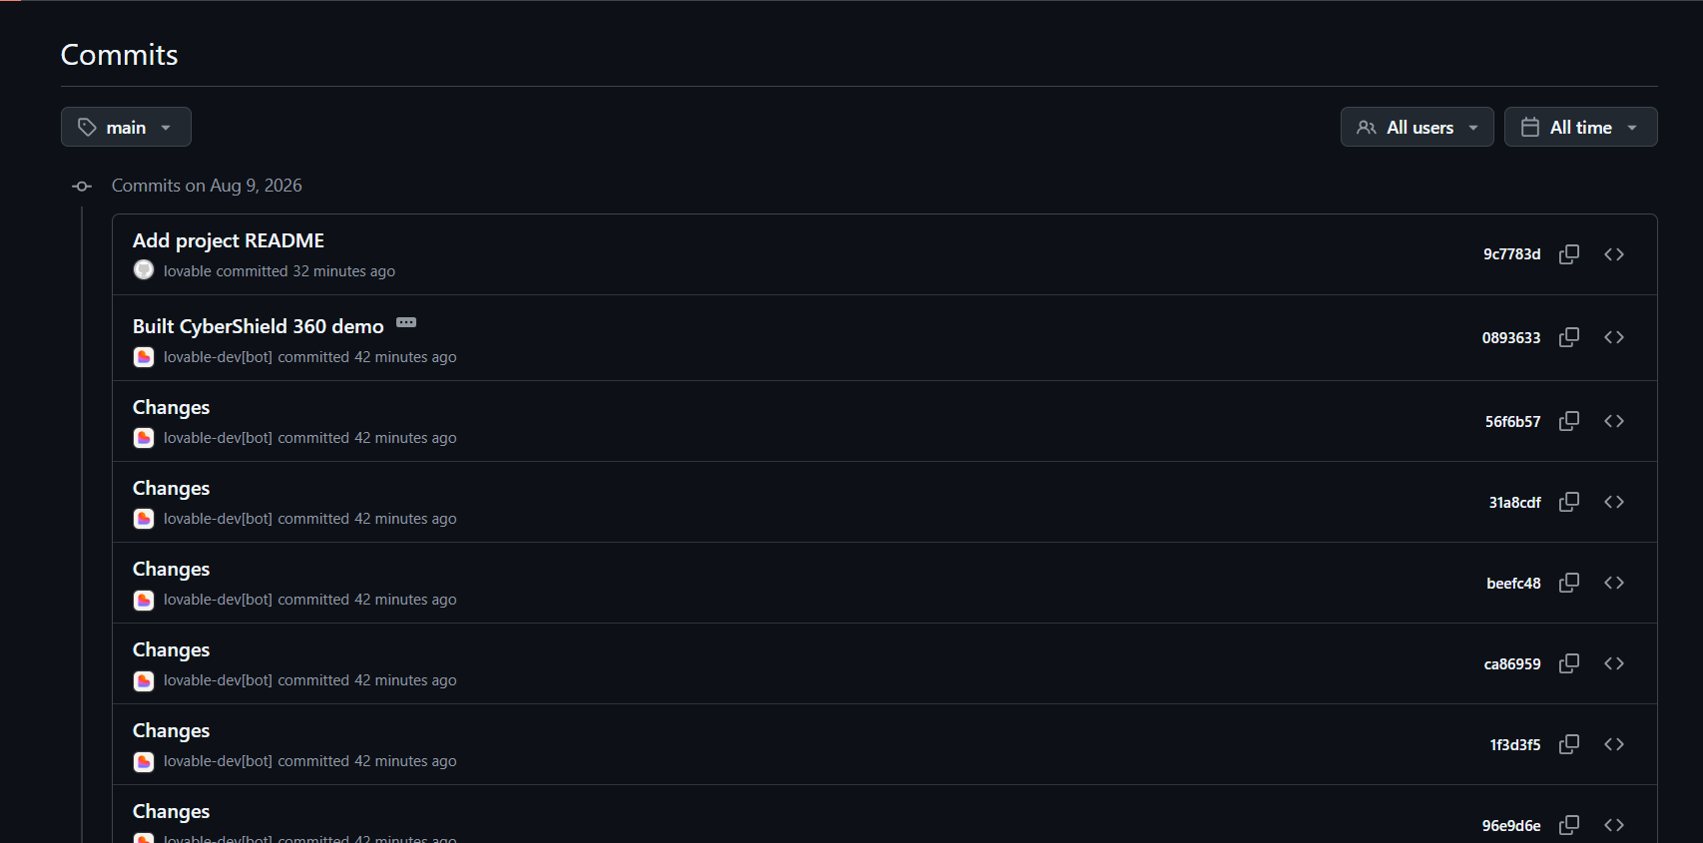

https://github.com/Surya220708/nexus-shield-view.git
